**[关于android SDK安装Failed to fetch URL http://dl-ssl.google.com/android/repository/addons\_list-1.xml出错](http://blog.csdn.net/springsky_/article/details/7442388)**

最近SDK出问题了，然后在google下载了一个android-sdk-windows.rar,然后点击SDK Manager，结果一直不能刷新API Level，然后就开始在网上找了好多资料，解决这个问题，修改 HOSTS,    HTTP  和  HTTPS  都不能解决，这给我带来了很大的困惑！   加载不出来的界面错误为：

**[html]** [view plaincopyprint?](http://blog.csdn.net/springsky_/article/details/7442388)

1. Fetching http://dl-ssl.google.com/android/repository/addons\_list-1.xml
2. Failed to fetch URL http://dl-ssl.google.com/android/repository/addons\_list-1.xml, reason: Connection to http://dl-ssl.google.com refused
3. Fetched Add-ons List successfully
4. Fetching URL: **<A** href="http://dl-ssl.google.com/android/repository/repository-6.xmlFailed" target=\_blank**>**http://dl-ssl.google.com/android/repository/repository-6.xml
5. Failed**</A>** to fetch URL **<A** href="http://dl-ssl.google.com/android/repository/repository-6.xml" target=\_blank**>**http://dl-ssl.google.com/android/repository/repository-6.xml**</A>**, reason: Connection to http://dl-ssl.google.com refused
6. Done loading packages.

Fetching http://dl-ssl.google.com/android/repository/addons\_list-1.xml

Failed to fetch URL http://dl-ssl.google.com/android/repository/addons\_list-1.xml, reason: Connection to http://dl-ssl.google.com refused

Fetched Add-ons List successfully

Fetching URL: [http://dl-ssl.google.com/android/repository/repository-6.xml](http://dl-ssl.google.com/android/repository/repository-6.xmlFailed" \t "_blank)

[Failed](http://dl-ssl.google.com/android/repository/repository-6.xmlFailed" \t "_blank) to fetch URL <http://dl-ssl.google.com/android/repository/repository-6.xml>, reason: Connection to http://dl-ssl.google.com refused

Done loading packages.

**[html]** [view plaincopyprint?](http://blog.csdn.net/springsky_/article/details/7442388)

1. Fetching **<A** href="http://dl-ssl.google.com/android/repository/addons\_list-1.xml" target=\_blank**>**https://dl-ssl.google.com/android/repository/addons\_list-1.xml**</A>**
2. Failed to fetch URL **<A** href="http://dl-ssl.google.com/android/repository/addons\_list-1.xml" target=\_blank**>**https://dl-ssl.google.com/android/repository/addons\_list-1.xml**</A>**, reason: Connection to **<A** href="http://dl-ssl.google.com" target=\_blank**>**https://dl-ssl.google.com**</A>** refused
3. Fetched Add-ons List successfully
4. Fetching URL: **<A** href="http://dl-ssl.google.com/android/repository/repository-6.xml" target=\_blank**>**https://dl-ssl.google.com/android/repository/repository-6.xml**</A>**
5. Failed to fetch URL **<A** href="http://dl-ssl.google.com/android/repository/repository-6.xml" target=\_blank**>**https://dl-ssl.google.com/android/repository/repository-6.xml**</A>**, reason: Connection to **<A** href="http://dl-ssl.google.com" target=\_blank**>**https://dl-ssl.google.com**</A>** refused
6. Done loading packages.

Fetching [https://dl-ssl.google.com/android/repository/addons\_list-1.xml](http://dl-ssl.google.com/android/repository/addons_list-1.xml)

Failed to fetch URL [https://dl-ssl.google.com/android/repository/addons\_list-1.xml](http://dl-ssl.google.com/android/repository/addons_list-1.xml), reason: Connection to [https://dl-ssl.google.com](http://dl-ssl.google.com) refused

Fetched Add-ons List successfully

Fetching URL: [https://dl-ssl.google.com/android/repository/repository-6.xml](http://dl-ssl.google.com/android/repository/repository-6.xml)

Failed to fetch URL [https://dl-ssl.google.com/android/repository/repository-6.xml](http://dl-ssl.google.com/android/repository/repository-6.xml), reason: Connection to [https://dl-ssl.google.com](http://dl-ssl.google.com) refused

Done loading packages.

我就纠结了，一直连接失败，难道是电信把google android屏蔽了，最近有一个想法，电信再怎么屏蔽android  但是不会屏蔽google搜索引擎的，如果电信把google搜索引擎屏蔽了，那电信估计也倒闭了！ 呵呵  我就做了一个选择  ，使用[www.google.com](http://www.google.com)做代理，详细看截图：

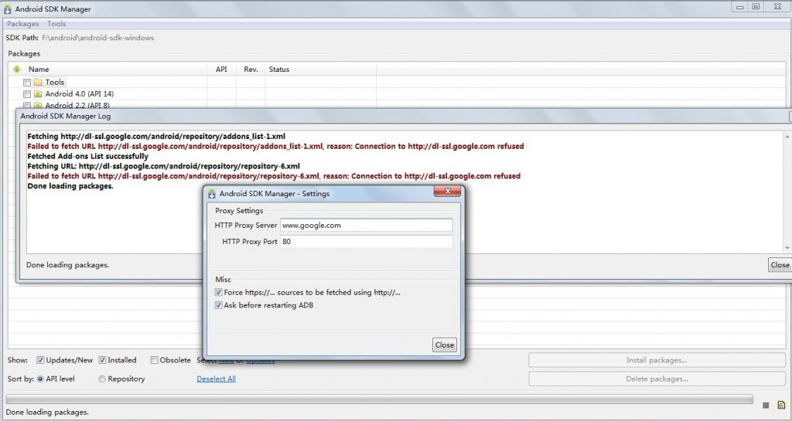

然后点击了一个package下的  reload  重新加载，呵呵  结果API level  全部出来了。